**HOW TO ASK GOOD QUESTIONS**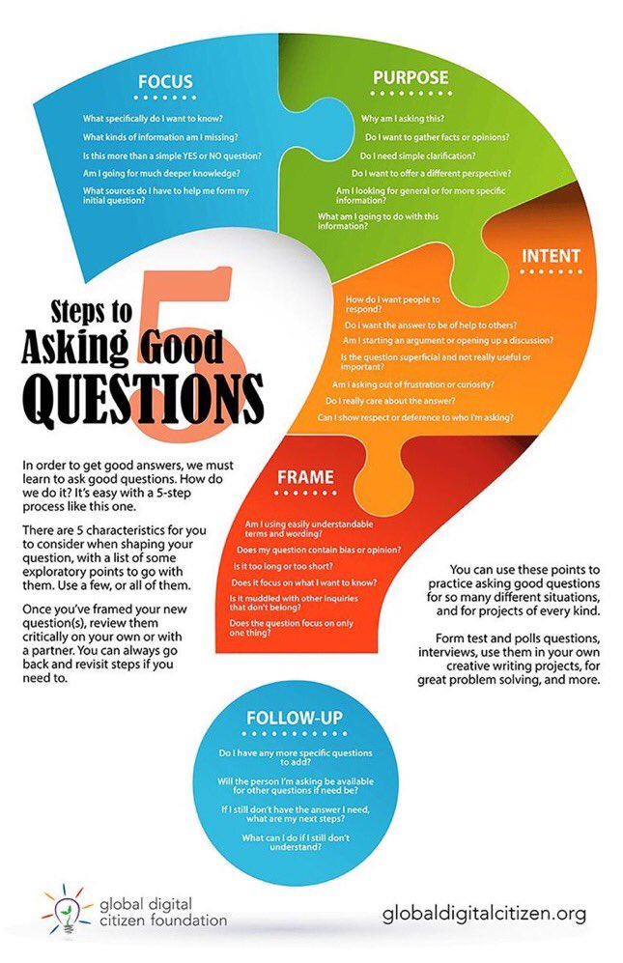

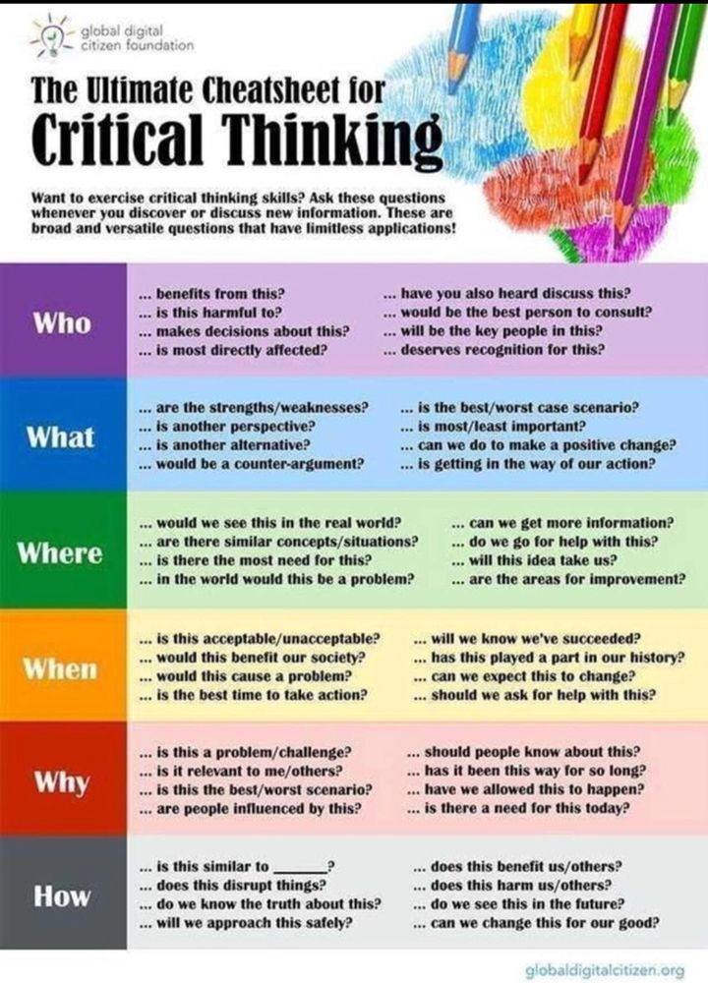

**GENERATIVE QUESTIONS**

**Helping Everyone Think Big, Think Differently, Think Strategically, Think Creatively**

Generative questions are open-ended and challenging with multiple answers and lines of inquiry. They build on previous experience and interests, identify relevant prior knowledge and understanding, open areas for exploration and investigation, focus thinking without cutting off possibilities, promote diverse ways of thinking and learning from each other, and integrate ideas across teams.

**Questions for Focusing Collective Attention to Get to Your “Why” and Big Ideas :**

1. What question, if answered, could make the most difference to (the societal problem(s) you are trying to solve)?
2. What’s important to you about it and why do you care?
3. What draws you/us to this inquiry?
4. What change must happen?
5. What’s our intention here? What’s the deeper purpose that is really worthy of our best efforts?
6. What opportunities can you see in this?
7. What do we know so far/still need to learn about it?
8. What are the dilemmas/opportunities in it?
9. What is our responsibility in dealing with this?
10. What assumptions do we need to test or challenge here in thinking about it?
11. What would someone who had a starkly different set of beliefs than we do say about it?

**Questions for Connecting Ideas and Finding Deeper Insight :**

1. What’s taking shape? What are you hearing underneath the variety of opinions expressed?
2. What’s in the center of the table?
3. What’s emerging for you? What new connections are you making?
4. What had real meaning for you from what you’ve heard? What surprised you? What challenged you?
5. What’s missing from this picture so far? What is it we’re not seeing? What do we need more clarity about?
6. What’s been your/our major learning, insight or discovery so far?
7. What’s the next level of thinking we need to do?
8. If there was one thing that hasn’t yet been said in order to reach a deeper level of understanding/clarity, what would that be?

**Questions That Create Forward Movement**

1. What would it take to create change on this issue?
2. Can we prioritize actions and consequences?
3. What could happen that would enable you/us to feel fully engaged and energized about it?
4. What’s possible here and who cares (rather that ‘what’s wrong and who’s responsible?’)
5. What needs our immediate attention going forward?
6. If we could guarantee our success, what bold steps might we choose?
7. How can we support each other in taking the next steps? What unique contribution can we each make?
8. What challenges might come our way and how might we meet them?
9. What conversation, if began today, could ripple out in a way that created new possibilities for the future?

*Note: These questions are the work of Michelle Clarke http://www.motivcoach.com/25- powerful-generative-questions