

**COMMUNICATION STYLES ACROSS CULTURES**

[](https://www.google.ch/url?sa=i&rct=j&q=&esrc=s&source=images&cd=&cad=rja&uact=8&ved=2ahUKEwjPlKGhitHdAhUILewKHcPvDIoQjRx6BAgBEAU&url=http://cdtermpaperxwtd.getfiredband.us/cooperating-and-communicating-across-cultures.html&psig=AOvVaw0Xg4apfougqWc-ihMWR0ET&ust=1537790495450590)

Implicit and explicit styles of communications often lead to misunderstandings and miscommunications. Many Western Cultures view a person who is being indirect as tricky, deceptive, and of questionable integrity. At best, Westerners consider indirect communication to be a waste of their time. On the other hand, those from implicit cultures see the explicit communication styles of Westerners to be rude, coarse, and insensitive.

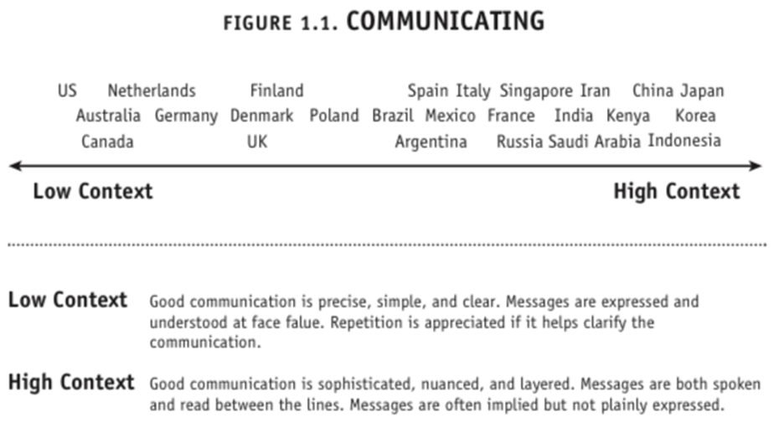

**Implicit Explicit**

**__________________________________________________________________________________**

**1 2 3 4 5 6 7 8 9 10**

|  |  |
| --- | --- |
| Value behavior over words. | Value words and documentation |
| Hold symbolism and propriety in high esteem | Use language pragmatically and with precision. |
| Rely on non-verbal and symbolic cues more than verbal and written cues. Importance of “small talk”. | View successful communication as being tied to the literal meaning of words. “Say what you mean” and “mean what you say”. Small talk is kept to a minimum. |
| Indirect and artful use of language. Communication is eloquent, nuanced and sophisticated. Allegories, metaphors, similes and storytelling are values. Leaders are evaluated on their oratory skills | Value succinct messages that are to-the-point. Good communication is precise, simple, explicit, accurate and clear. |
| Require contextual information about those with whom you are communicating or conducting business. | Require little contextual information about those with whom you are communicating or conducting business. |
| Rely heavily on hidden, implicit, contextual cues such as nonverbal behavior (body language, tone of voice), social context, nature of interpersonal relationships, and status | Oral communication is supported by detailed written documentation. |
| Less is put in writing, more is left to open interpretation (reading between the lines) | Repetition is appreciated for purposes of clarification, as is putting messages in writing. |
| Tip for low context cultures :Don’t assume the message is contained in spoken words + Pay as much attention to what is not said as to what is said | Tips for high-context cultures: Don’t assume the message extends beyond spoken words + Be especially careful when working with other high-context cultures…contextual cues differ across cultures |

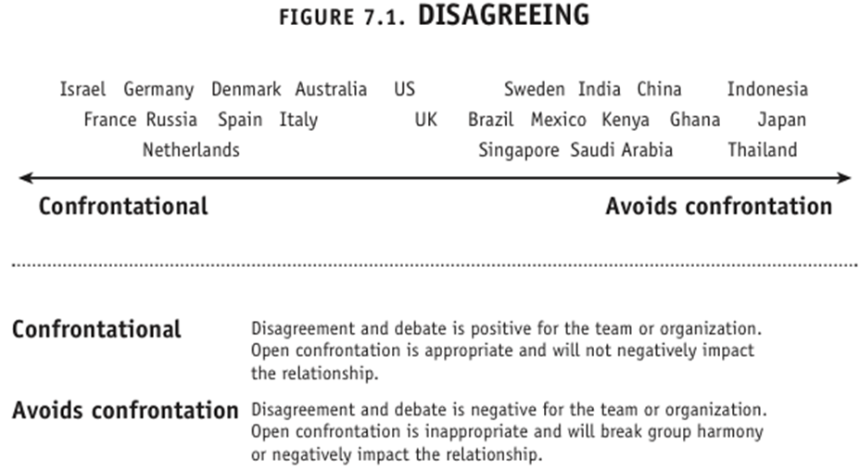

**Direct/ confrontational Indirect/ conflict avoidance**

**__________________________________________________________________________________**

**1 2 3 4 5 6 7 8 9 10**

|  |  |
| --- | --- |
| Handle conflict in a direct and explicit manner. | Handle conflict implicitly by avoiding direct confrontations. |
| View conflict situations as impersonal issues that need to be approached openly to reach a resolution. | View conflictual situations as a threat to personal dignity and/ or integrity. |
| View conflicts as positive and constructive, seeing open conflict as constructive and beneficial (as long as it is expressed factually). Enjoy debates. | Prefer passive resistance or the use of informal mediators such as lawyers, arbitrators, colleagues, friends, etc to resolve contentious issues. |
| Link direct conflict management with honesty and trustworthiness. | See open conflict as detrimental to the parties involved. |
| Use multiple upgraders in order to strengthen their disagreement, such as totally, completely, absolutely. | Use downgraders: maybe, perhaps, a little bit, partially, what do you think? I don’t know—to soften the disagreement. |
| **In a Confrontational culture:**  •  Don’t assume that disagreement with an idea means disapproval of you  •  View disagreement as an indication of interest in a topic  •  Distinguish emotional expressiveness from confrontation – speaking with passion is not the same as disagreeing  •  Don’t mimic a confrontational style | **In a Avoids Conflict culture:**  •  Connect with team members prior to meetings so that disagreement can be expressed 1-on-1  •  Use multiple downgraders… (Maybe, perhaps, I don’t know, what do you think?) |

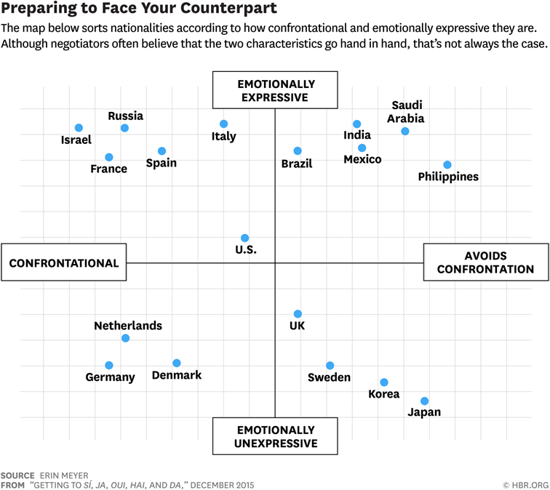

**Expressive Neutral**

**__________________________________________________________________________________**

**1 2 3 4 5 6 7 8 9 10**

|  |  |
| --- | --- |
| Value demonstrative expression in the workplace | Value factual, objective and pragmatic exchanges of information. |
| View expression and expressiveness as playing an integral role in persuasion of colleagues. | See communication as issue centered, impersonal and goal-oriented. |
| Expect positive and negative emotions to run high in the workplace. | Prefer an emotionally detached way of presenting information as a method of persuasion. |
| Be quite animated in your use of words and body language. | Doubt professionalism and credibility of colleagues who are emotionally expressive. |
| Evaluate the credibility and trustworthiness of coworkers and business partners based on their display of human qualities. | View work relationships as being different from social relationships, and therefore evaluate colleagues on their direct and measurable contribution to the business. |
| Display and accentuation of emotions are key components of the communication process. Emotional connectedness is essential (sensation of having CONNECTED). Expressiveness may be raised to the level of an art form. | What is said is placed above how it is said. Attention to detail and accuracy and a dispassionate, objective style are expected- cf British keeping a stiff upperlip- or German Sachlichkeit. |

**Formal Informal**

**__________________________________________________________________________________**

**1 2 3 4 5 6 7 8 9 10**

|  |  |
| --- | --- |
| Observe specific rules of etiquette in the workplace and business situations, specifically with superiors. | Value casual, relaxed and friendly conduct in the workplace. |
| Expect subordinates to be mindful of etiquette when interacting with them. | View etiquette, decorum and tradition as obstacles in developing relationships. |
| View formalities and social conventions as a conduit to effective communication and the development of business and social relationships. | Link credibility and trustworthiness to a casual and friendly style. |
| Judge colleagues with a more informal communication style as unprofessional and lacking in social graces. | View formalities and social conventions as barriers to effective communication. |
| Be keenly aware of the social structures in which you operate. | Be uncomfortable in informal situations and excluded by those who follow rules and social conventions. |
| Status symbols (car, dress, accessories) are cues to others about your rank in the society. | Status symbols, titles & honorifics, and social etiquette are less important |